**APPLIED PHYSICS LAB**



**Topic: Refraction Through a Mirror**

***Submitted To Instructor Physics Lab: Mrs. Rubina Nasir***

***Submitted By Group No. 07***

**S No. Name Roll Number**

**1. Muhammad Hassaan Ch. 242811**

**(Leader)**

**2. Siraj Ali 242814**

**(Member)**

**3. Muhammad Hassan 242817**

**(Member)**

**4. Ahmad Kaleem Bhatti 242820**

**(Member)**

**5. Ayesha Naeem 242823**

**(Member)**

**6. Saba Hussain 242775**

**(Member)**

***BSCSev-F-24-A Department of Computer Science Page | 1***

# ***Task # 7***

* **Apparatus**

1. Ray Optics Kit
2. Optics Light Source
3. Protractor
4. Acrylic Rhomboid Template Page

* **Objective**

The experiment aims to validate the Law of Refraction, determine the angle of reflection and refraction, and verify Snell's law by calculating the refractive index of a given medium.

* **Procedure**

|  |  |
| --- | --- |
| 1. Print a copy of the Lab Report page that has the "Acrylic Rhomboid Template" and place it on the table. Put the acrylic rhomboid piece on top of the illustration. 2. Place the Basic Optics Light Source on the paper and shine a single ray of light along the illustrated incident ray. 3. Trace the ray that comes out at the other side of the acrylic. 4. Remove the acrylic piece and connect the two rays to show the path that light followed while inside the acrylic. 5. Make arrows on the rays to illustrate the direction of travel. 6. Analyze the side labeled ‘Interface 1’: This is the first bending of the light, as it traveled from air into the acrylic.  * Use the protractor to measure the angle of refraction that the light ray makes with the normal line at this interface. Record it in the Data Table. | optix 026 |

1. Analyze the side labeled ‘Interface 2’: This is the second bending of the light, as it traveled from inside the acrylic back out into the air.



* At the point where the light ray exited the acrylic, use the protractor to trace the normal line to the surface at that point. Extend the line to the inside of the acrylic.
* Use the protractor to measure the angles of incidence and refraction with respect to the normal line at this interface. Record them in the Data Table.

1. Repeat the process for an initial incident angle larger than 45° and then for an initial incident angle smaller than 45°.

* It may help to print a new template for each trial. Use the available ‘Extra Rhomboid Template’ for the repetitions.
* Use different color pencils, if available, to distinguish the trials if working all in the same template.
* **Graph**
* Open the DataStudio file **Index of Refraction.ds**.
* Enter the values for the angles in air and the angles in acrylic into the data tables. Notice that it does not matter whether the air or the acrylic was the incident of the refractive side. Just make sure you enter them in the correct table: ‘In AIR’ or ‘In ACRYLIC’.
* The program will calculate the sine of the angles and will automatically plot the  versus . Click the ‘Fit’ button on the graph toolbar and select to do a ‘Linear fit’ of the data.
* The slope of the graph, *m*, will be shown in a box. Record the slope value as your calculated value of the index of refraction of the acrylic.
* **Results**

|  |  |  |
| --- | --- | --- |
| Angle of Incidence | Angle of Reflection | Refractive Index  n |
| 28° | 11° | 2.49 |
| 30° | 14° | 2.08 |
| 41° | 19° | 2.21 |

* **For Finding Refractive Index, we used sinθi / sinθr = n.**
* **Discussion**

**Law of Refraction (Snell's Law)**

The Law of Refraction, commonly known as Snell’s Law, describes how light bends when it passes from one transparent medium to another with different optical densities. This phenomenon occurs due to the change in the speed of light in different media.

***BSCSev-F-24-A Department of Computer Science Page | 3***

**Principle: Snell’s Law**

Snell’s Law mathematically relates the angles of incidence and refraction to the refractive indices of the two media:

**n1sinθ1=n2sinθ**

Where:

* n1​ and n2​ are the refractive indices of the first and second media, respectively.
* θ1 is the angle of incidence (measured from the normal).
* θ2 ​ is the angle of refraction (measured from the normal).

**Behavior of Light**

1. **Towards the Normal**  
   When light travels from a less dense medium (e.g., air) to a more dense medium (e.g., glass or water), it slows down and bends *towards the normal*.
2. **Away from the Normal**  
   Conversely, when light passes from a denser medium to a less dense medium, it speeds up and bends *away from the normal*.

**Connection to the Experiment**

In the experiment:

1. **Light Bending**
   * The observed bending of the light at the interface between two media confirmed Snell's Law.
   * The degree of bending (refraction) depended on the refractive indices of the materials used (e.g., air and glass).
2. **Critical Angle and Total Internal Reflection**
   * At certain angles, the refracted ray was observed along the boundary, corresponding to the **critical angle**.
   * When the angle of incidence exceeded the critical angle, total internal reflection occurred, demonstrating the complementary nature of reflection and refraction.
3. **Proportionality Check**  
   The experiment verified the proportionality between the sine of the angles and the refractive indices, validating the equation.

**Surface Dependency**

* **Smooth Interfaces**: Provided accurate refraction angles, highlighting the predictable nature of Snell’s Law.
* **Rough Interfaces**: Caused scattering, which slightly distorted the refraction results but underscored the importance of surface quality in optical experiments.

***BSCSev-F-24-A Department of Computer Science Page | 4***

* **Conclusion**

“The experiment successfully demonstrated the principles of the Law of Refraction:

1. Light bends at the boundary between two media due to a change in its speed, as predicted by Snell’s Law.
2. The angles of incidence and refraction followed the proportional relationship dictated by the refractive indices.
3. The critical angle and total internal reflection were observed, further reinforcing the connection between refraction and reflection.”

* **Precautions**
* Ensure that the surfaces of the refracting material (e.g., glass slab or prism) are clean and free from dust or fingerprints to avoid scattering or distortion of the light.
* Place the light source and the medium correctly so that the light ray strikes the surface at the intended angle of incidence.
* Draw the normal (perpendicular line) precisely at the point of incidence to measure angles accurately.
* Conduct the experiment in a dimly lit environment to avoid interference from external light sources, which may affect the visibility of refracted rays.
* Mark the light rays and angles with a fine-tipped pencil or marker for better accuracy during measurements.
* **Conclusion**

The experiment demonstrated how a galvanometer, initially limited to measuring small currents, could be converted into an ammeter by using a parallel shunt resistor. This conversion not only highlighted the principles of current division but also showed the importance of calibration and precision in electrical measurements. By carefully calculating the shunt resistance, we successfully extended the utility of the galvanometer while protecting it from damage due to excessive current.

* **References**

1. [**Halliday, D., Resnick, R., & Walker, J. (2014).** *Fundamentals of physics* (10th ed.). Wiley.](https://elearn.daffodilvarsity.edu.bd/pluginfile.php/987150/mod_label/intro/fundamentals-of-physics-textbook.pdf)
2. **Punjab Curriculum Textbook Board. (2023).** Physics 11th. Punjab Curriculum Textbook Board.
3. [**Punjab Curriculum Textbook Board. (2018).** Physics 10th. Punjab Curriculum Textbook Board.](https://drive.google.com/file/d/15BNgMeeVTOKT7hgUYR95UhP89JjXkB3y/view.)
4. [**Serway, R. A., & Jewett, J. W. (2004).** *Physics for scientists and engineers* (6th ed.). Thomson Brooks/Cole.](https://faculty.ksu.edu.sa/sites/default/files/physics_serway.pdf)

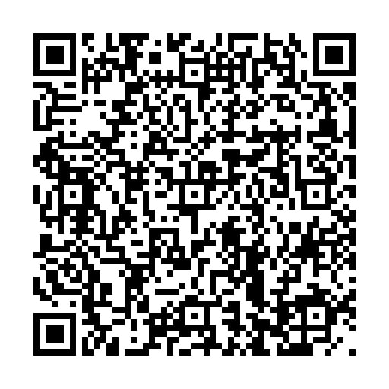

(Scan now for References and Practical Examples)

***BSCSev-F-24-A Department of Computer Science Page | 5***